**What is automation?**

Automation, in its essence, involves**leveraging technology, software, or machinery to carry out tasks that would typically require human effort**. The beauty of automation lies in its ability to minimize or eliminate the need for constant human intervention, allowing processes to run smoothly and efficiently.

**Why is automation such a game-changer?**  
Because it revolutionizes the way businesses and individuals operate. It leads to increased efficiency and improved accuracy by reducing human errors and streamlining processes. Automation allows organizations to cut costs, enhance scalability, and provide 24x7 operations. By automating repetitive tasks, employees can focus on more strategic and creative responsibilities, leading to higher job satisfaction.

**Automation categories**

**Robotic Process Automation (RPA)**

Through Robotic Process Automation (RPA), the creation of **software robots that mimic human actions** and effortlessly **engage with digital systems** becomes possible.

RPA enables organizations to automate tasks across a diverse range of applications and systems, including legacy systems, web applications, and desktop applications.

**Task Automation**

Task automation targets **repetitive and mundane tasks**such as data entry, data extraction, file management, and document processing.  
  
By automating these routine activities, you not only save valuable time and resources but also minimize the risk of errors, allowing you to dedicate your focus to the most critical tasks.

**Business Process Automation**

UiPath empowers organizations to **automate entire business processes by seamlessly connecting multiple tasks and systems**.

By implementing UiPath, your department or team can experience streamlined workflows, enhanced operational efficiency, and consistent execution of processes.

**Test Automation**

With Test Automation, organizations can automate the **testing of their applications and systems**, revolutionizing software quality.

Automated testing speeds up release cycles and reduces the time and effort spent on manual testing.

**AI and Machine Learning Integration**

By integrating automation with AI and machine learning services, users can**incorporate intelligent automation into their workflows**.

This includes leveraging natural language processing, digital image processing, and predictive analytics.

**Process Mining and Discovery**

Process mining and discovery tools, empower organizations to **identify and analyze their existing processes**.

This valuable insight leads organizations to the most promising opportunities for automation, enabling them to scale up their automation initiatives and prioritize projects with the greatest impact.

**How can automation help me?**

**Job satisfaction**  
By automating repetitive tasks, you not only escape the burnout and boredom cycle but also gain precious time to dedicate to more engaging and fulfilling work

**Skill development**  
With automation handling mundane tasks, you have the perfect opportunity to embrace personal growth, learn new skills, and embrace higher-value roles within your organization.

**Enhanced opportunities**  
Embracing automation and related technologies can greatly enhance your value in the job market, opening doors to exciting career opportunities and unlocking new pathways for professional growth.

**Reduced stress**  
Letting automation handle mundane tasks gives you the freedom to embrace a healthier work-life balance, experiencing reduced stress and more time for what truly matters.

**How can automation help my organization?**

Here are six main reasons for your organization to embrace automation:

**Saved cost**  
Automation brings valuable benefits to businesses by reducing labor costs and enabling teams to allocate their time and resources to more strategic and high-value activities.

**Improved accuracy**  
With software robots, businesses can significantly reduce errors. This results in the generation of high-quality data, enabling informed decision-making and driving substantial improvements in overall business performance.

**Increased efficiency**  
Robots excel at lightning-fast task execution, resulting in quicker turnaround times and enhanced output.

**Enhanced compliance**  
By implementing standardized processes and generating automated audit trails, automation not only ensures adherence to regulations and internal policies but also offers a sigh of relief for your organization.

**Improved scalability**  
One of the most impressive aspects of automation is its remarkable scalability, allowing organizations to effortlessly adapt to fluctuations in demand and navigate business needs with ease.

**Optimizing resource allocation**  
Having their routine tasks automated, employees can focus on strategic, creative, and customer-centric endeavors. This unlocks higher productivity and fosters a culture of innovation, driving business success.

**Fully unattended**

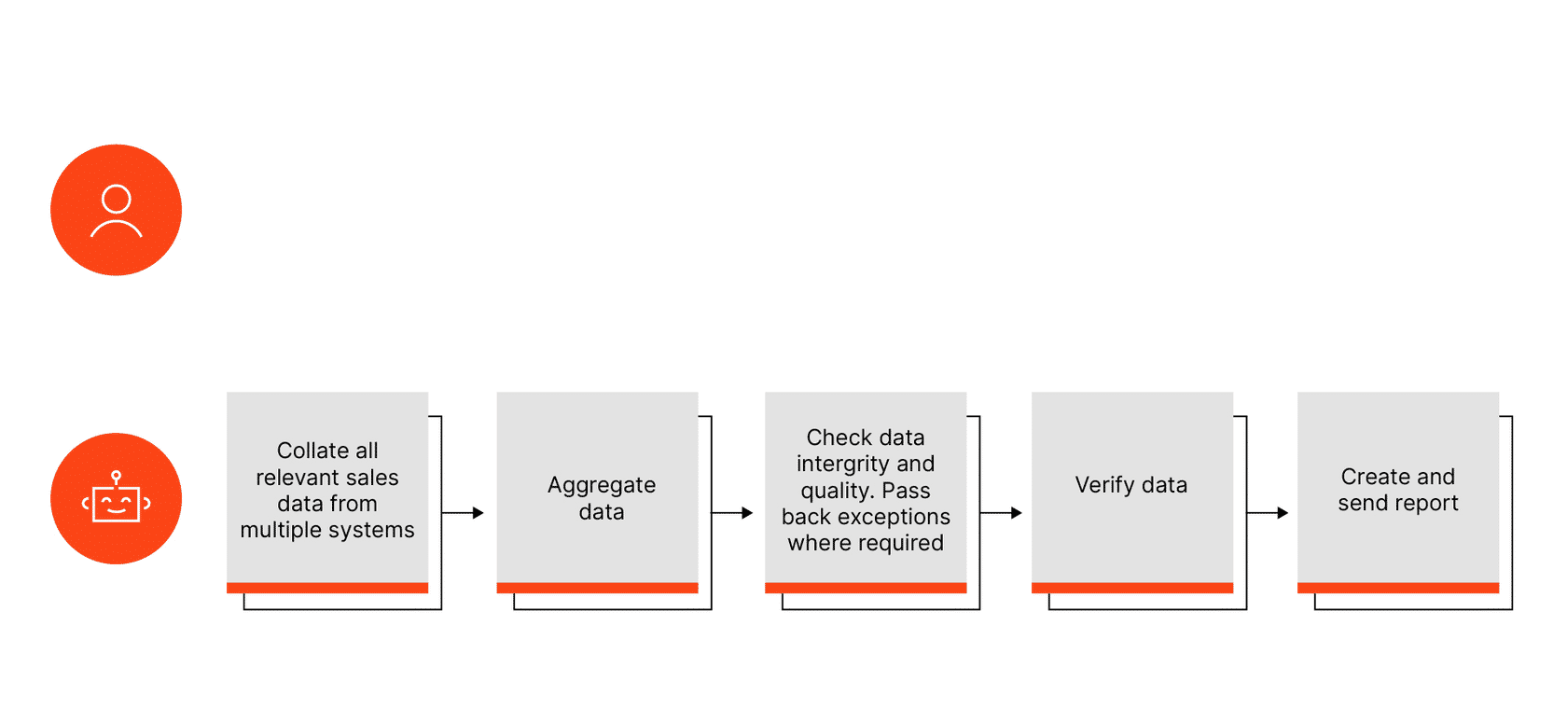

Automation is a game-changer for handling massive amounts of data. Moving and processing data manually across various systems is time-consuming and error-prone. Fully Unattended robots are the perfect solution. They handle data processing without human intervention, ensuring efficiency and accuracy.

**Let's consider a real-life scenario**. A global financial services company needs to collate sales figures from multiple systems, including ERP, CRM, and sales databases, every month. It's a labor-intensive task.

Enter Fully Unattended automation! The unattended robot completes the entire process, improving accuracy and timeliness in generating the final report for senior management.

**In this automation model, the unattended robot:**

* Launches automatically based on triggers or schedules.
* Is centrally managed by a workflow orchestrator for 24x7 operation.
* Executes the same process consistently and alerts you only when exceptions occur.
* You play a role in orchestrating the process initially and contributing as needed.

**Partially unattended**

Tired of tedious and repetitive business processes? This automation model offers a solution! Start with human involvement and then hand off the rest to a Partially Unattended robot. This frees you to focus on high-value activities while ensuring the process is completed successfully with thorough documentation and notifications.

**Consider a real-life example:** Mortgage appraisals. Ordering them manually is time-consuming and prone to mistakes. However, with Partially Unattended automation, lenders initiate the process and the robot takes over. Appraisal time is significantly reduced, leading to cost savings and fewer mortgage escalations.

**In this automation model, the partially unattended robot can:**

* Take over scheduled tasks or upon your instruction.
* Handle preparatory work and process initiation.
* Program complex business rules.
* Provide data validation and assurance.
* Notify you only in case of exceptions.

**Human in the loop**

Certain process types requiring intermittent human intervention and complex decision-making can be challenging to automate with traditional tools. However, with this automation model, business rules are embedded into the process, allowing the robot to perform tasks and prompt for input only when necessary, simplifying your role.

**Let's take for example an invoice processing use-case.**  In invoice processing, OCR technology is used to capture information from scanned invoices. However, if the data quality is low, automation alerts you to review and validate the information before entering it into the ERP system. By combining RPA with AI, the system learns from your validations, reducing the need for future intervention.

**In this model, the unattended robot can:**

* Initiate processes based on schedules or triggers.
* Request your input when needed.
* Resume the process after you've completed your task.
* Repeat this cycle as required within the process.

**Attended, interval**

In this automation model, the attended robot can launch on-demand, run processes from the robot tray, and mimic your actions precisely. The only drawback is that sometimes your machine is occupied during the robot's task. However, you can use the free time for offline tasks.

**Let's consider a real-life banking scenario:** Debit cards at a bank may be declined for 81 reasons. Smooth customer experience relies on efficient call handling by our staff, explaining the reason. Previously, staff faced a cumbersome process of navigating screens, writing down, and calculating data to provide answers. Now, an attended robot swiftly performs these tasks, instantly presenting employees with a clear description of the declined card's reason.

**In this model, the attended robot can:**

* Launch on-demand using mouse clicks or hotkeys.
* Run the process directly from the UiPath Assistant.
* Complete the task in exactly the same way as you would.
* Complete the task and return the process to you.

**Attended in tandem**

In certain situations, it may not be practical or efficient for a robot to take control of your machine. Instead, consider the Attended in Tandem automation model. This approach allows the robot to work alongside you, providing valuable information while you focus on your primary tasks

**In a customer service scenario**, agents often face the challenge of navigating multiple systems during customer calls. This process can be time-consuming and prone to errors, leading to frustrations for both the agent and the customer.

With Attended in Tandem automation, agents can seamlessly handle customer queries while the robot operates in the background. The robot accesses, compiles, and presents the necessary information, enabling agents to address customer needs more efficiently. This boosts productivity, reduces resolution times, and ultimately enhances customer satisfaction.

**In this model, your attended robot can:**

* Trigger and execute processes.
* Monitor your activities and launch processes automatically.
* Run processes directly from the UiPath Assistant (App).
* Execute processes while you continue working on the machine.

**Hybrid automation**

Hybrid automation merges attended and unattended robots within a unified platform. Attended robots assist customer-facing tasks, while unattended robots handle heavy back-end processing. It automates end-to-end business processes, providing flexibility and scalability.

**Take this example:** Sales teams can leverage UiPath's Hybrid automation for improved productivity. Attended automation monitors activities, capturing relevant data. At regular intervals or in real-time, the attended robot transfers information to an unattended robot for further processing and sales report generation.

**In the hybrid automation model, you can:**

* Launch an attended robot from your machine.
* Connect attended and unattended robots.
* Trigger an unattended robot with an attended robot.
* Involve both attended and unattended robots when further action is needed.
* Automate attended and unattended robot collaboration when no human intervention is necessary.